PROJECT -1
STUDENT SCHOLARSHIP MESSAGE
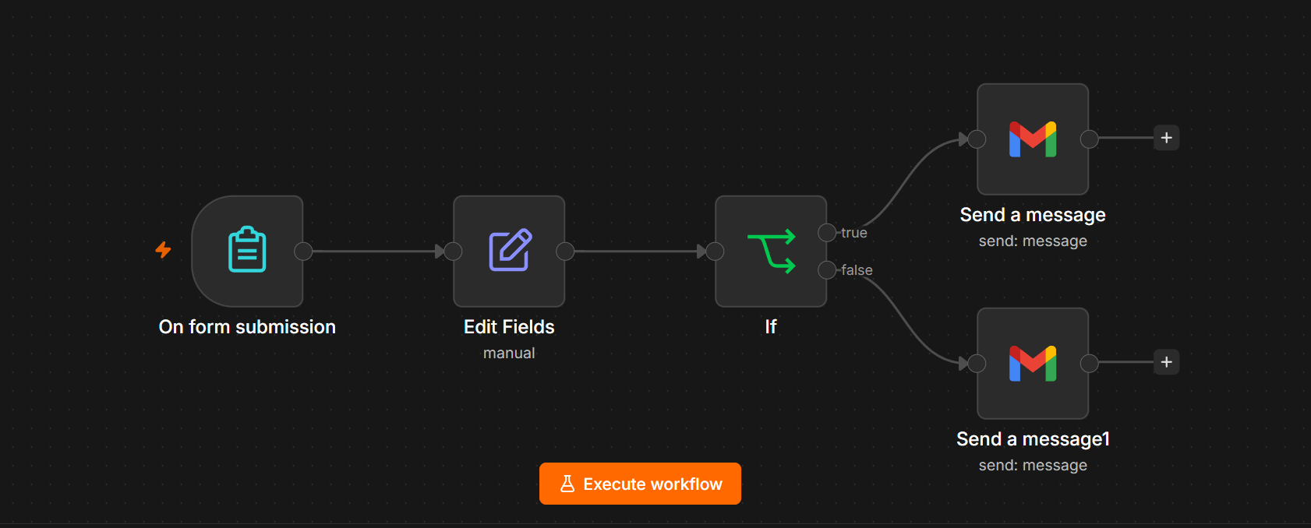
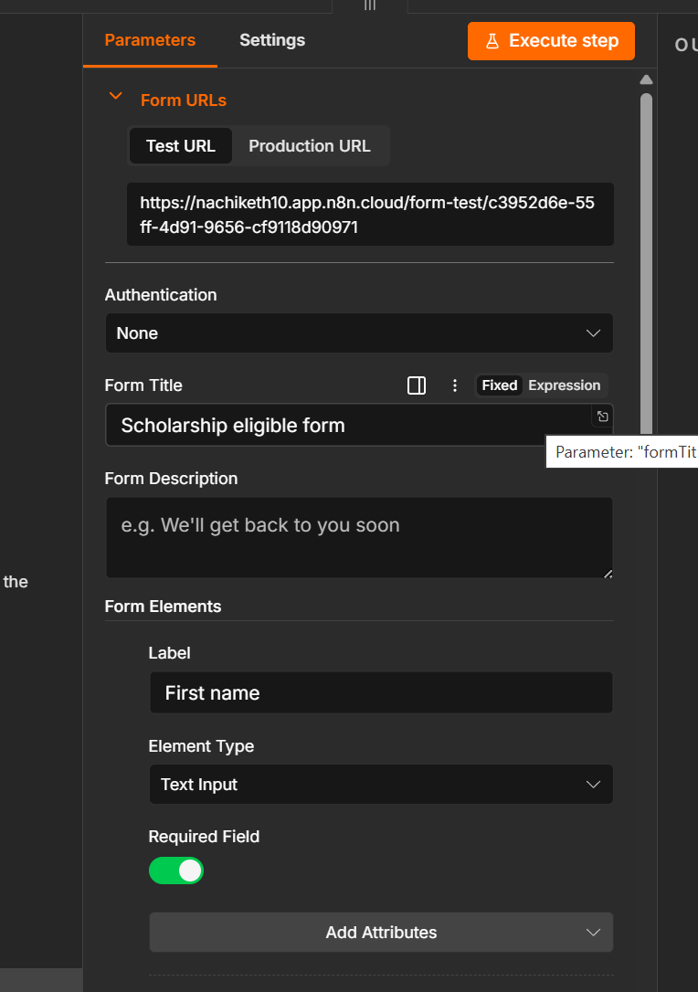
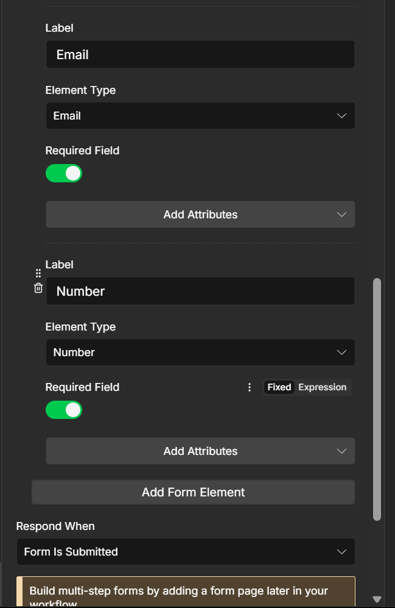
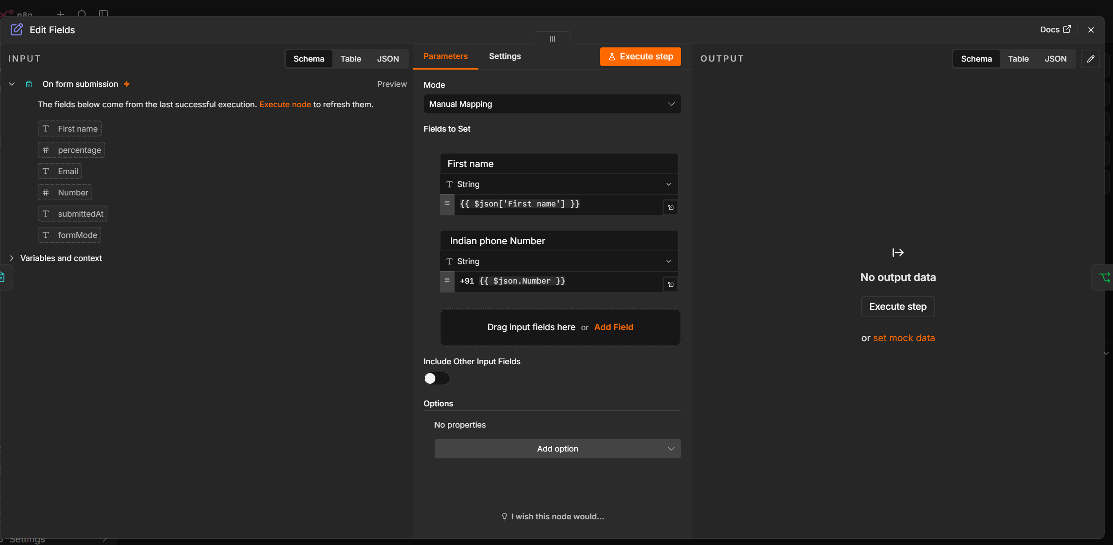
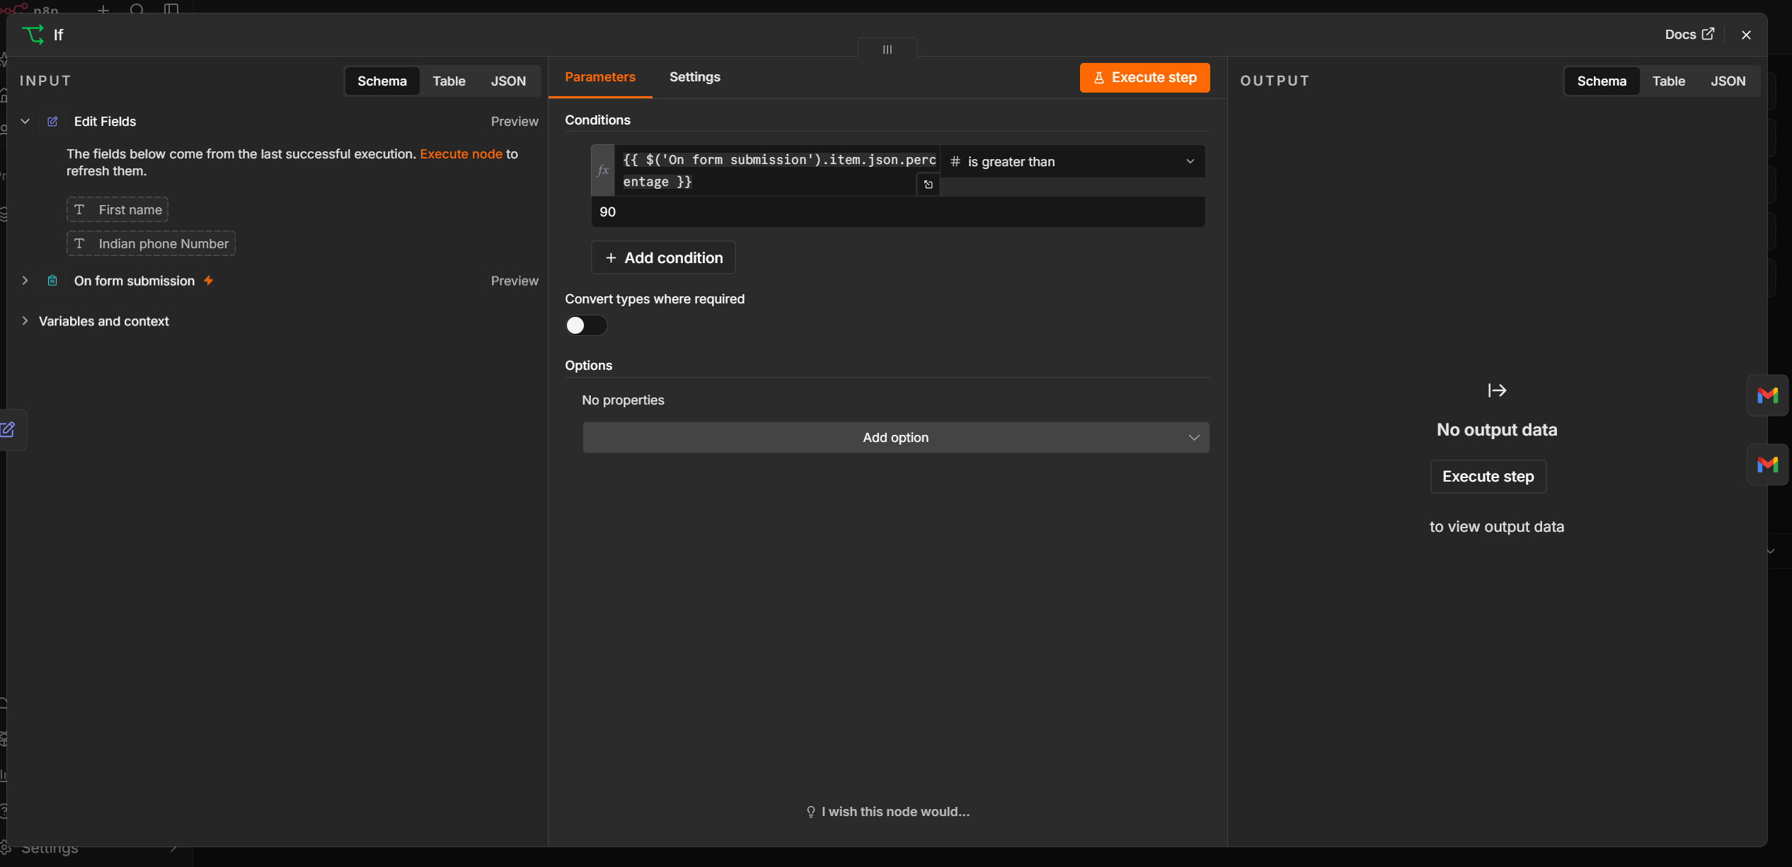
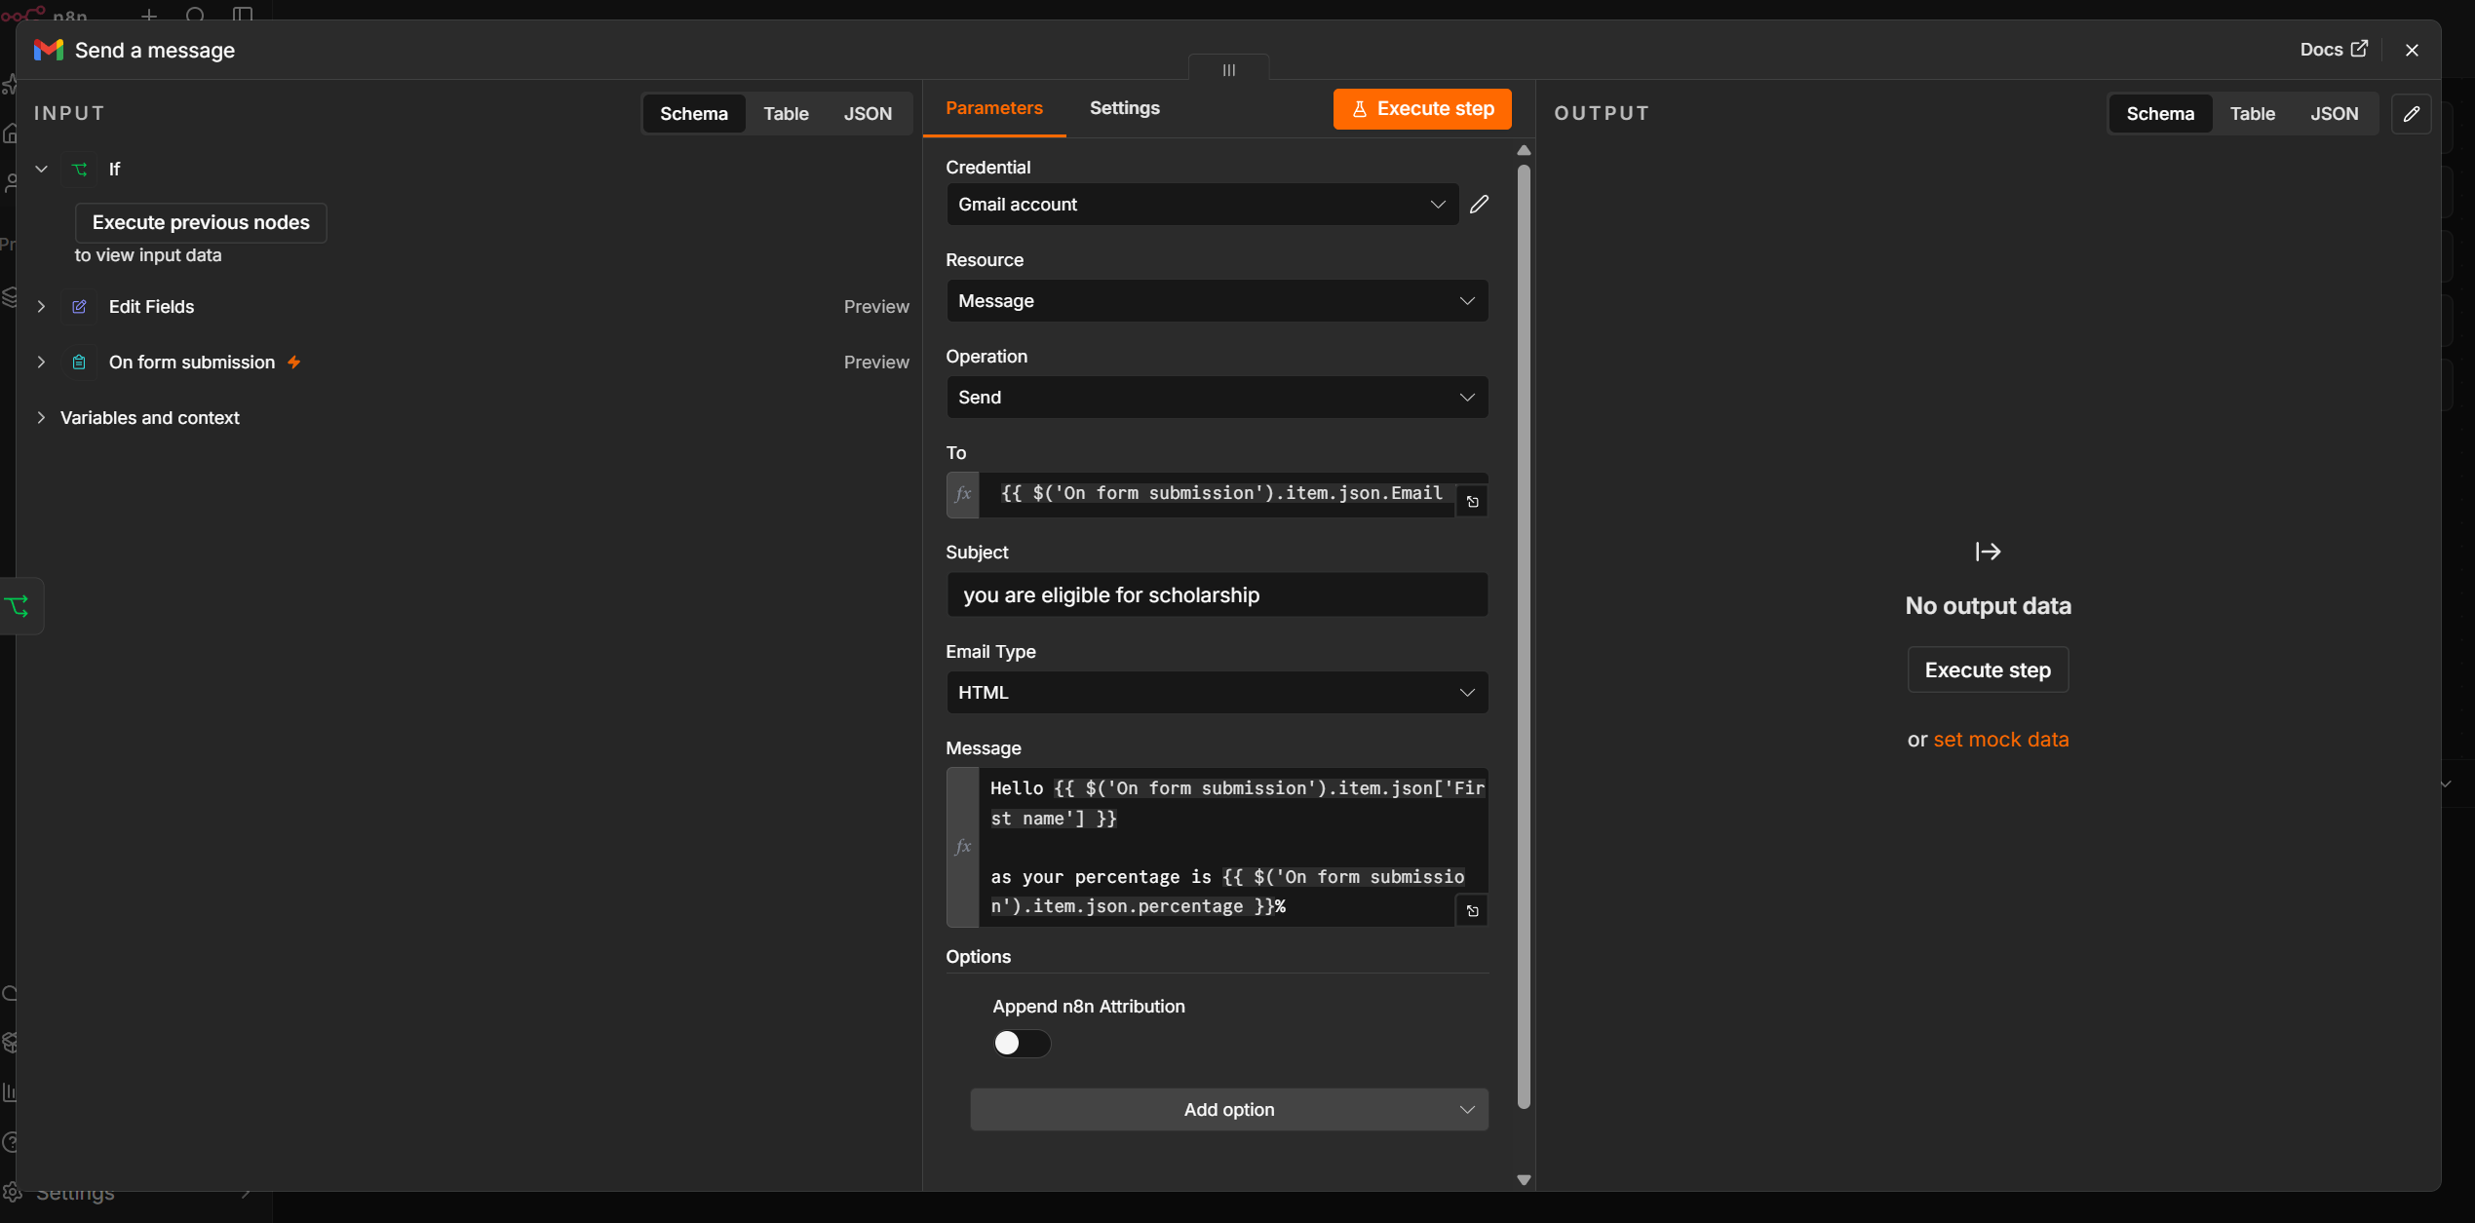
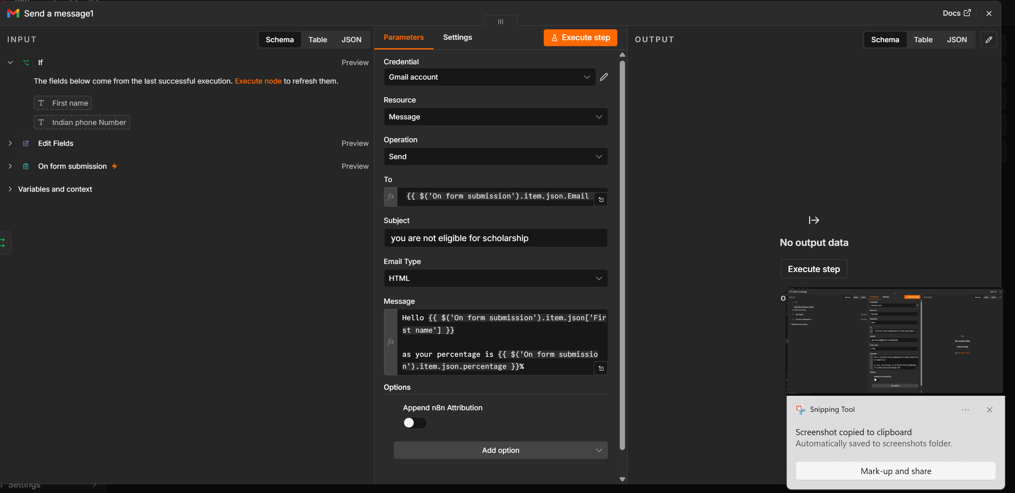
Project Information
Project Title: Automated Email Notification System using n8n
Platform: n8n
Purpose:
This workflow automates the process of receiving form submissions, evaluating user data based on predefined conditions, and sending different email notifications depending on whether the condition is satisfied.

1. Overview
This automation is designed to streamline communication after a user submits an online form. The workflow captures form data, formats or edits the submitted information, evaluates a condition using an If node, and sends an appropriate email through Gmail.
The workflow can be used for:
- Student admission confirmation
- Job application responses
- Event registrations
- Leave approval notifications
- Customer inquiry responses
- Payment confirmations

2. Workflow Architecture
User Submits Form
│
▼
On Form Submission
│
▼
Edit Fields
│
▼
If Node
┌────┴─────┐
│ │
TRUE FALSE
│ │
▼ ▼
Success Rejection
Email Email

3. Workflow Components
Node 1: On Form Submission
Purpose
The On Form Submission node acts as the workflow trigger. It starts automatically whenever a user submits the form.
Input
Example Form Fields:
- Full Name
- Email Address
- Phone Number
- Department
- Status
- Any additional fields
Sample Input
{
"name": "John Doe",
"email": "john@gmail.com",
"department": "Computer Science",
"status": "Approved"
}
Output
The submitted form data is passed to the Edit Fields node.

Node 2: Edit Fields
Purpose
The Edit Fields node modifies, renames, or formats the incoming data before it is evaluated.
Possible Operations
- Rename fields
- Remove unwanted data
- Format text
- Create new fields
- Prepare data for email templates
Example
Input:
{
"fullName": "John Doe",
"mail": "john@gmail.com"
}
Output:
{
"Name": "John Doe",
"Email": "john@gmail.com"
}
Benefits
- Standardizes field names.
- Simplifies later workflow steps.
- Improves data consistency.

Node 3: If Node
Purpose
The If node evaluates a predefined condition and routes the workflow accordingly.
Example Conditions
Status = Approved
or
Marks >= 50
or
Department = Computer Science
Decision Flow
If the condition is True, the workflow proceeds to the success email node.
If the condition is False, the workflow proceeds to the rejection or alternate email node.

Node 4: Gmail – Send a Message (True Path)
Purpose
Sends a positive or approval email when the condition evaluates to True.
Example Subject
Application Approved
Example Email
Hello John Doe,

Congratulations!

Your application has been approved successfully.

Thank you for your submission.

Regards,
Administration Team
Trigger
Executed only when the If node returns True.

Node 5: Gmail – Send a Message (False Path)
Purpose
Sends an alternative email when the condition evaluates to False.
Example Subject
Application Update
Example Email
Hello John Doe,

Thank you for your application.

Unfortunately, your application does not meet the current eligibility requirements.

We encourage you to apply again in the future.

Regards,
Administration Team
Trigger
Executed only when the If node returns False.

4. Complete Workflow
User submits form
│
▼
Workflow Trigger
│
▼
Edit submitted fields
│
▼
Evaluate condition
│
┌─────┴─────┐
│ │
True False
│ │
▼ ▼
Send Send
Approval Rejection
Email Email
│
▼
Workflow Ends

5. Sample Input
{
"name": "Alice Smith",
"email": "alice@example.com",
"status": "Approved"
}

6. Decision Example
Status | Workflow Path | Email Sent
Approved | True | Approval Email
Rejected | False | Rejection Email

7. Technologies Used
Technology | Purpose
n8n | Workflow Automation
Form Trigger | Capture Form Submissions
Edit Fields Node | Format and prepare data
If Node | Conditional logic and branching
Gmail API | Send email notifications
JSON | Data exchange format

8. Advantages
- Automates email communication after form submissions.
- Eliminates manual follow-up emails.
- Supports conditional workflows for different outcomes.
- Provides consistent and timely notifications.
- Easily customizable for various business processes.
- Scalable for handling large numbers of submissions.

9. Possible Enhancements
- Store submission data in Google Sheets or a database.
- Send SMS or WhatsApp notifications in addition to email.
- Notify administrators when a form is submitted.
- Add AI-based validation or classification before sending emails.
- Attach generated PDF reports or certificates.
- Integrate with CRM systems such as Salesforce or HubSpot.
- Add approval workflows with multiple decision levels.
- Include timestamps and tracking IDs in notification emails.

10. Conclusion
This n8n workflow provides an automated email notification system that begins with a form submission, processes and standardizes the submitted data, evaluates it against predefined conditions, and sends the appropriate email based on the outcome. By automating these tasks, the workflow improves efficiency, reduces manual effort, ensures consistent communication, and enhances the overall user experience.

